Manoa Chocolate

Deb

CS-3300

09 SEP 2023

Technical Lead Documentation

**Overview:**  
 In this documentation, you will find GE’s with the purpose of learning how to work with teammates by simulating a software industries work environment. Also, you will find instructions,remarks and troubleshooting steps that the team had to reasearch and resolve during the current GE.

**Table of Contents**

* 1. **GE01**-Agile Teams and Version Control

**GE01**-Agile Teams and Version Control

**Ge01 Tech Lead-Alan Sanchez**

**Introduction:**

In this GE01, the team manoa chocolate was task to install multiple programs, research agile team concepts, basic Python code language,establish repositories and other functions in github website, and learn version control by using git bash. The purpose of these tasks were to get accustomed to the software facilities that team will be using until the end of the semester.

**Installation:**  
The software installs are the following:

* + Python
  + Visual Code
  + GitHub Desktop
  + Git Bash

To install python, the teach lead instructed to some members that didn’t have python already to download python from the official website <https://www.python.org/> and go to downloads and follow the process giving by the website.

To install the IDE for python, the team agreed to download Visual Code. The official website is <https://code.visualstudio.com/> and by going to downloads you can start the process to install it in your windows. Though, it is important to check the versions and what systems are you using such as Mac or windows.

Everybody confirmed that they have an account in Github and download the Github desktop by following the steps given by Github.

To install Git, the team download the software from <https://git-scm.com/> and follow the steps given by git.

**Processes**

**Git to GitHub:**

In order to link git to a Github repository, go to the file where your local repositories of git hub are in git bash by using the unix commad CD “file”. There use the Git command git clone “repository URL”. There you will download all the files from the desired repository to your local file and you will be linked to it.

**Saving changes and updating Github with git**  
 The team learn by trial and error to save changes in our local files and publish those changes in website repositories by using the following commands:

* 1. Git add . Or git add “file” to tell git what file is about to be saved and push.
  2. Git commit- to save changes in the local files
  3. Git push- to publish these saves into the official repository

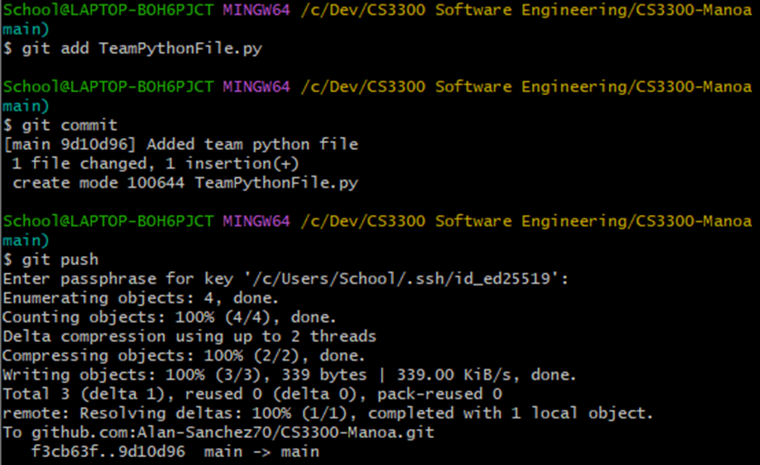

The resource that the team use to find these commands is

<https://www.atlassian.com/git/tutorials/saving-changes>

**Merging Branches**  
 In order to merge an individual branch to the shared main branch is by using the command git merge . after this git will be ready to merge the current branch to the main branch. Before merging, Git will want us to save all changes first and resolve any conflicts that may prevent git to merge. In order to check what are these conflicts and future changes to files we use the command git status.

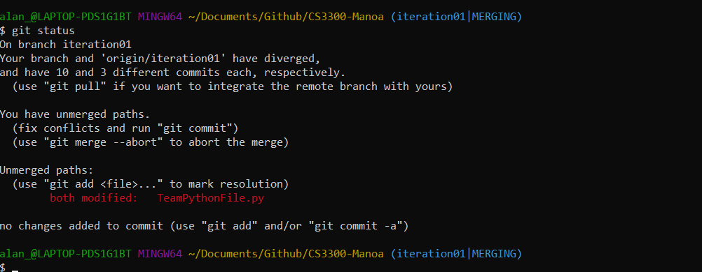

The resource used for the information is <https://www.atlassian.com/git/tutorials/using-branches/git-merge>

**Concepts:**

The team discussed about agile collaboration and how to learn together in a team. Also, it was discussed version control and the reason as for what are we using it. Our individual thoughts about what we learned about these concepts were written in the actual GE01 assignment.

**Python Code and Unix Commands**

We learned basic python coding skill in the Python pair programming lecture. Where all instructions and definitions in how to use certain functions were explore and explained by the teammember by reasearch or scrum coach and tech lead help. Hence the website were we learned and based our concepts from python. https://www.learnpython.org/en/Hello%2C_World%21

The tech lead and scrum coach offered assistance to unix commands in order to move,remove,copy, and add files to the repository through git bash. Although, the team members did their research and were able to use unix commands.

**Conflicts**

In this section, the team solve conflicts and troubleshoot its way to success. These conflicts with their solutions are the following:

A member was having issues finding the webiste because of different browser and couldn’t find the right files. Thus,we solve this issue by going to Github desktop and go to repositories and click on open in command line which will give you and error but in that error the proper link to git shall be found.

The team was having issues with linking to the repository by cloning it to the wrong pathfile. We make sure that we clone at the actual local github files.

The team find out that cloning a repository through URL its easier and faster than SSH, but SSH is more secure.

The team struggled with how we saved changes. The commands needs to be exactly as the documentation says. Otherwise, it will not be saved and cause issues when merging.

The team realized that they could be conflicts when team member saved their changes in a close interval. Thus, an error will show up explaining that the reference repository have extra files or modification that the local files don’t have and needs to be updated. In order to fix this issue use the command git pull to get all changes from the main reference.

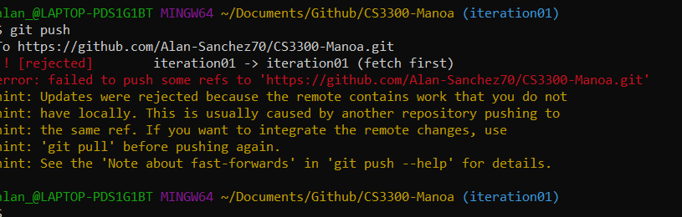

The misunderstood part of the assignment, where we though we all change the same branch and that the main branch to merge with different branches. However, this misunderstatement was clarified and we understood that the individual branches should be merged to the original.

The team realized that when a member merged their changes to main and you pull later. Some files will have certain code, signs and hex numbers. In order to fix this, you have to remove to extra random lines of codes that showed up. Then, save and merge.

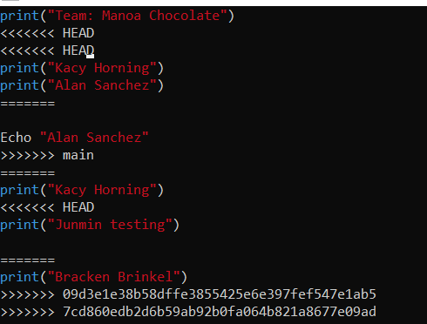  
 The tech lead for this GE is Alan Sanchez, next tech lead is Braken B.

All turned in their tech documentation besides Yumin Z.

09/09/2023  
**Additional resources for this GE**

* <https://www.freecodecamp.org/news/how-to-setup-virtual-environments-in-python/#:~:text=Python%20virtual%20environments%20give%20you,and%20makes%20it%20easily%20reproducible.> - Explains the set up and summary of Python’s virtual environments.
* <https://realpython.com/python-dicts/> - Summarizes the use of dictionaries in Python.
* <https://www.geeksforgeeks.org/regular-expression-python-examples-set-1/> - Summaries what Regular Expressions are in Python and how they are used.
* <https://www.atlassian.com/git/tutorials/inspecting-a-repository/git-tag#:~:text=Tagging%20is%20generally%20used%20to,no%20further%20history%20of%20commits.> - Summarizes what tags are in Git and GitHub
* <https://www.atlassian.com/git/tutorials/what-is-git> - Gives a summary of what Git is and its history.
* <https://docs.github.com/en/get-started/using-git/about-git> - Gave me info about how Git and GitHub work together.
* <https://www.atlassian.com/git/tutorials/saving-changes#:~:text=The%20git%20add%20command%20adds,until%20you%20run%20git%20commit%20.> - Explained more about how git add works, how it adds files to get updated.